Archimedes Bathtub
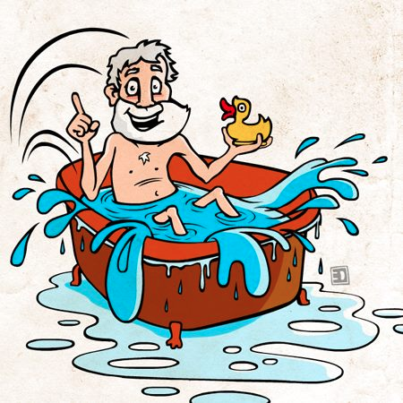

Let’s find the density of our student volunteers! First we will find their mass, then dunk them in the tub to find their volume. From there we can calculate their density. Do you think the boys or the girls will have more density?

- Write your hypothesis: ______________________________________________________________
__________________________________________________________________________________________________________________________________________________________________________________

- Density is the measure of how “heavy” something is for its “size”, or how compact it is. Write the formula for density: ________________________________________________________________________________________

Data Table
Name of Student | Mass | Volume | Density

- What differences did you see between the densities of boys and girls? __________________________________________________________________________________________________________________________________________________________________________________

- What similarities did you see between the densities of the boys and girls?
__________________________________________________________________________________________________________________________________________________________________________________

- Average Densities of the boys and girls. To find the average density, add up all the densities of the boys and then divide by the number of boys. To find the average density of the girls, add up all their densities and then divide by the number of girls.
Average Boy density: _______________
Average Girl Density: _______________

- Conclusion: (was your hypothesis correct?) ___________________________________________________________________________________________________________________________________________________________________________________________________________________________________________________________________________

 | P2 | P3 | P4 | P5 | P6
Tank Guide #1

Tank Guide #2

Ladder

Faucet

RR Girl

RR Boy

Bucket #1

Bucket #2

Bucket #3

Bucket #4

Camera

Data Recorder

